L03_Hillary_Dreyer Bruton_ITAI2372

Proof of Completed Lab:

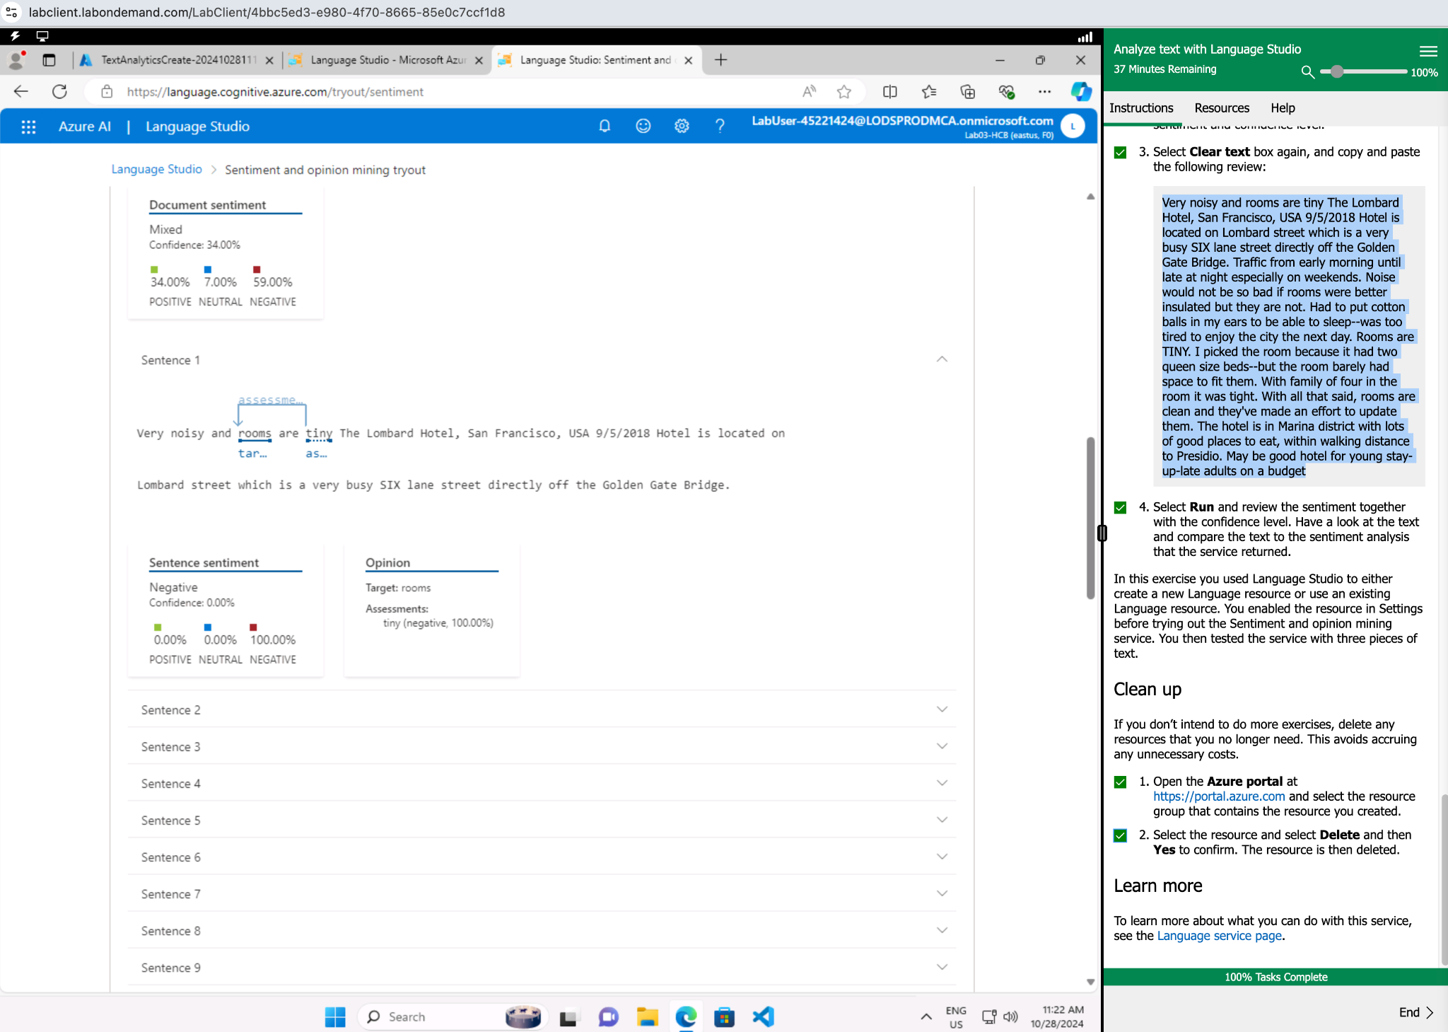

Lab 02 Reflective Journal:

What did I learn?

* How to set up a language resource
* How to analyze text for sentiment with Language Studio.
* I learned that the tool analyzes sentiment at both the sentence and document level.

What were the challenges I faced?

I did not face any challenges in this lab. This lab was short and easy to follow. Additionally, as I’ve become more familiar with the Azure terminology and how to create a resource, the steps have become easier to follow.

What insights were gleaned?

In my career as a professional communicator, I have used sentiment analysis for several years. It is imperative for a communicator to filter through sometime millions of comments, articles, retweets, likes, reposts, etc. Being able to perform a sentiment analysis quickly often informs the direction of a communications campaign. In the same vein, using a tool like this to address one off comments more granularly/specifically is also a benefit.